Josh Grier MuSpAn Hackathon Notes
- Estimated Shape of met regions using alpha shapes around tumour epithelial cells – Adding_Detailed_Met_Shapes.ipynb
- Labelled cell centres and boundaries as whether they lie inside a met region and which one – Becky’s Day2-fix-mets
- Calculated distances from each cell centre to each met boundary – saved these separately for cells inside each Met, and for those outside the mets I saved the distances to the nearest met and separately saved the distance to each specific met – Distance_to_met_calcuator.ipynb
- Made pipeline to estimate distribution of cells of a certain type relative to the met boundary – inside met regions distances are recorded as negative, outside they are recorded as positive – KDEs.ipynb
- I used this to look at the distribution of WNT high and low cells – see notebook. And also to look at the distribution of Kupffer cells – see end of doc
- I wrote a script to plot these distributions coloured by depth of the met to see if there was any relationship between size of met and the distribution of the cells and found that WNT-high cells tend to skew towards the met boundary increasing as met size increases, whereas the opposite occurs with WNT low cells, there is still a skew towards the met boundary but this decreases with size - KDEs_normalised_and_coloured_by_met_size.ipynb
- The problem with the kde approach is that, inside the met, the regions closest to the boundary are significantly larger than those near the centre and so we would expect to find more cells in those regions, therefore I also wanted to investigate the relative density and see if the story remained the same - Relative_Densities.ipynb. This gave a much less clear picture, with most mets seeming to have a relatively even distribution of the WNT cells. Some of the larger mets had a skew towards the boundary for WNT-high cells but the largest met had a relatively even distribution of WNT-high cells, whilst the WNT-low cells were skewed towards the boundary
- I also looked at how the monocyte vs Kupffer transcript marker scores varied with distance from the met boundary in infiltrating macrophages and Kupffer cells to try to investigate whether the Kupffer cells transition towards a monocyte population as they move towards the met. The results and pipeline is in Monocyte_vs_kupffer_expression.ipynb, but I would need help from a biologist to interpret the results and further analysis may be needed

4d old:
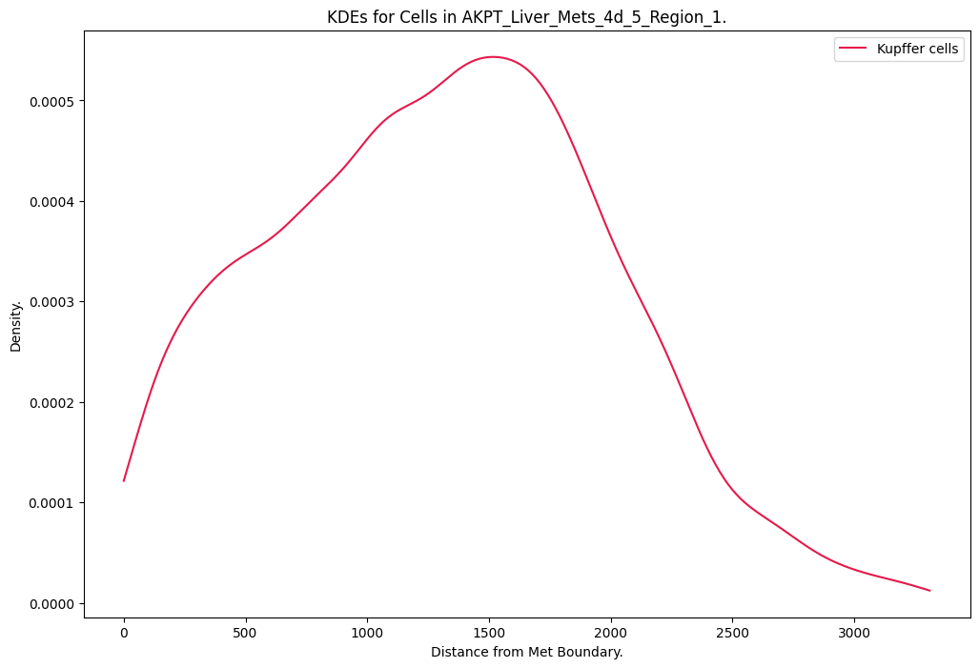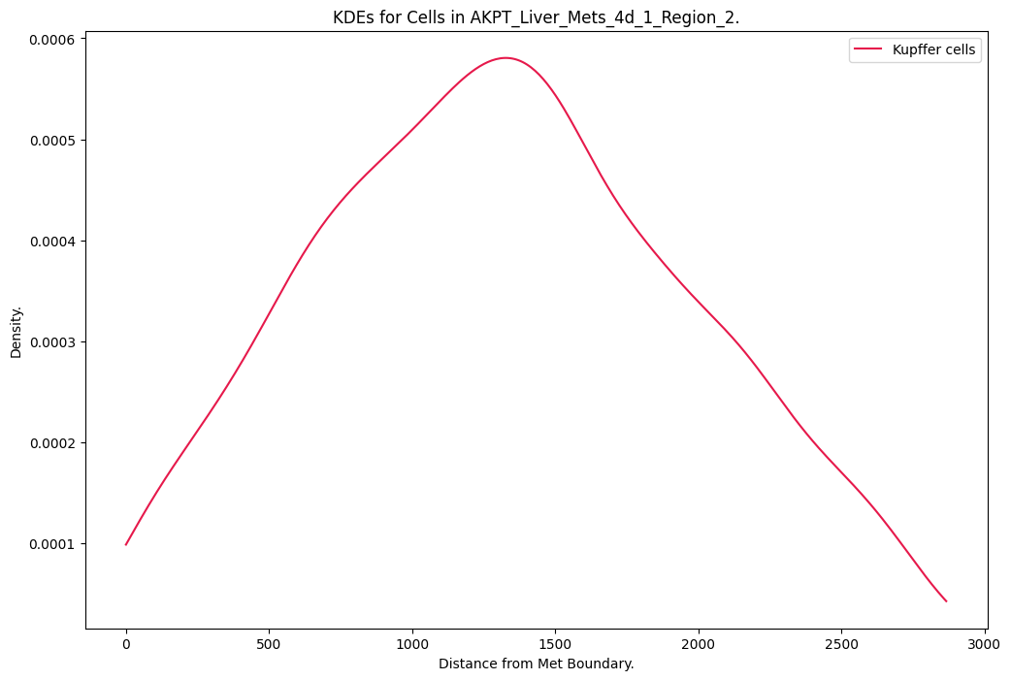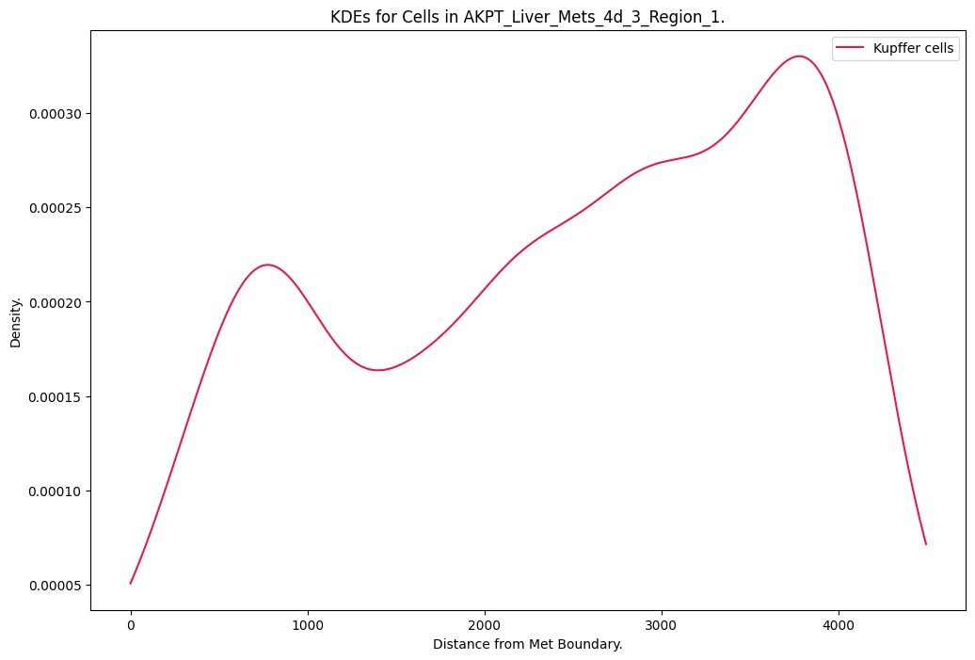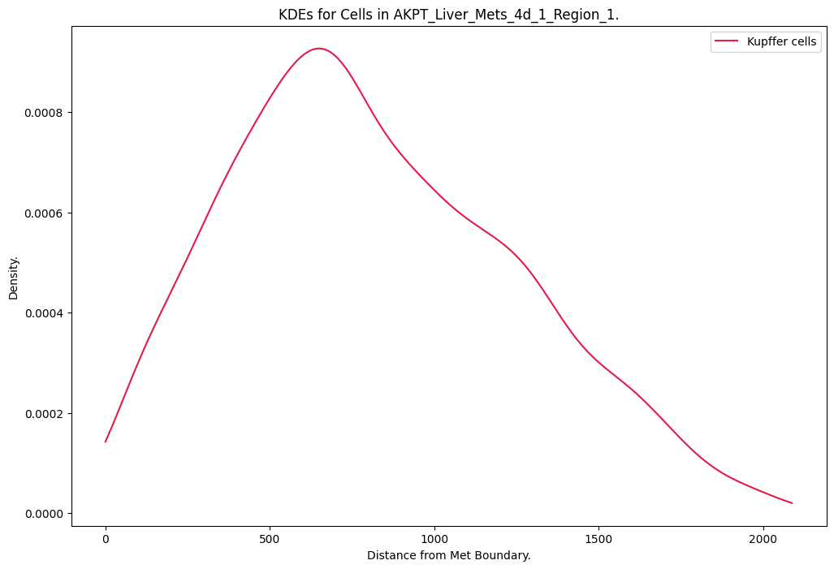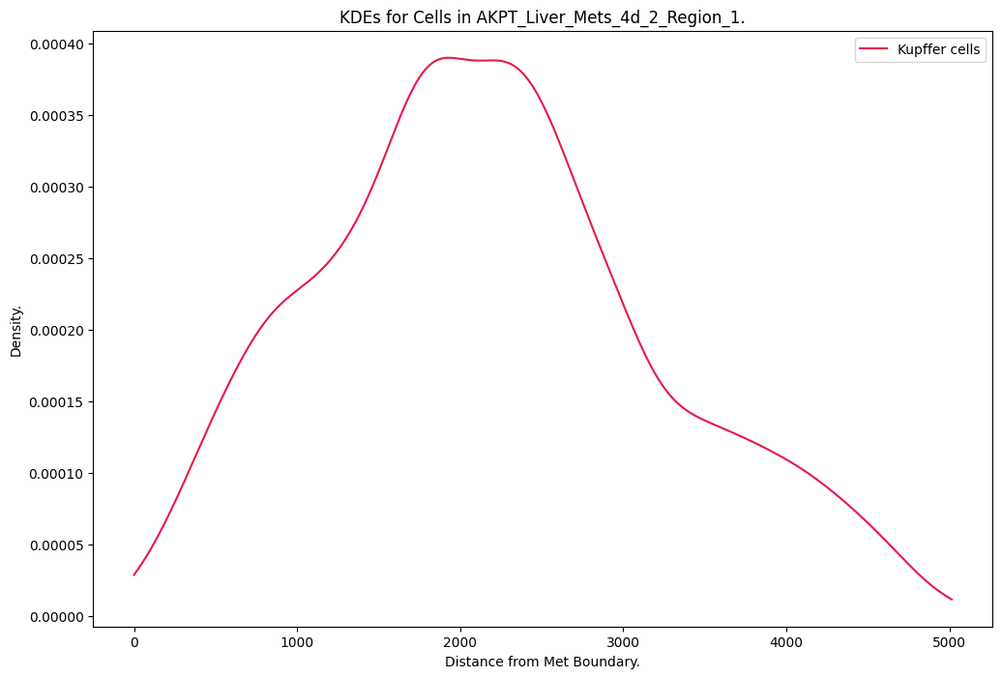

28d old:
